BP5: PFam vs Blast
1. Introduction
The identification of orthologous and paralogous proteins within a proteome is a foundational task in bioinformatics. Two primary methodologies exist for this purpose: BLAST (Basic Local Alignment Search Tool), which utilizes local pairwise sequence alignment, and HMMs (Hidden Markov Models), which utilize statistical profiles derived from multiple sequence alignments.

This study analyzes the Globin family (PF00042) within the Homo sapiens proteome. Globins are heme-containing proteins characterized by the "globin fold," comprising a diverse family that includes Hemoglobins, Myoglobins, and distantly related sensor proteins like Neuroglobin. This report compares the completeness of family retrieval using the PFam HMM versus BLAST searches using three distinct query sequences: Hemoglobin Alpha, Hemoglobin Zeta, and Hemoglobin Delta.
2. Methods
- HMM Search: The InterPro/PFam database was queried for accession PF00042 (Globin) within Homo sapiens. Results were filtered for "Reviewed" (Swiss-Prot) status.
- BLAST Search: BLASTp searches were performed via NCBI against the Reference proteins (refseq_protein) database restricted to Homo sapiens (taxid:9606).
- Queries: Three distinct paralogs were selected as queries to test search sensitivity:
  - Hemoglobin subunit alpha (HBA1)
  - Hemoglobin subunit zeta (HBZ)
  - Hemoglobin subunit delta (HBD)
3. Results
3.1 Establishing the Baseline (PFam HMM)
The PFam HMM search identified 12 distinct, verified Globin proteins in the human proteome. The HMM successfully grouped all members—including the distant Neuroglobin and Cytoglobin—into a single family based on the conserved globin fold structure.

3.2 BLAST Search Results
Experiment A: Query using Hemoglobin Subunit Alpha (HBA1)
When querying with the standard Hemoglobin Alpha, BLAST easily identified the core Hemoglobin cluster. As shown in Figure 1, the top 9 hits (including Alpha, Theta, Zeta, Mu, Delta, Beta, Gamma) displayed extremely high significance, with E-values ranging from 9e-101 to 1e-27. However, the search failed to identify distant relatives like Myoglobin or Neuroglobin in this top list.

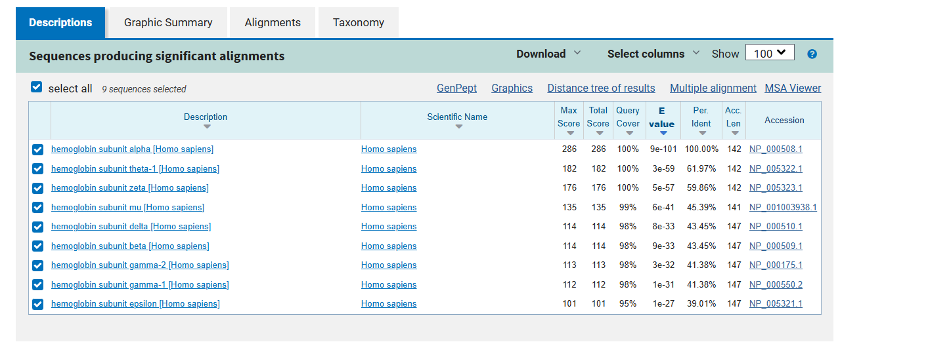
Figure 1: BLASTp results for Hemoglobin Subunit Alpha. The search identifies closely related hemoglobins with high significance but excludes distant family members.
Experiment B: Query using Hemoglobin Subunit Zeta (HBZ)
Querying with the embryonic Hemoglobin Zeta yielded a slightly broader recovery. As shown in Figure 2, the search identified the entire Alpha and Beta hemoglobin clusters. Notably, unlike the Alpha search, this query successfully captured Myoglobin at the very bottom of the significant list (E-value 7e-16). However, the distant relatives Neuroglobin and Cytoglobin were still absent.
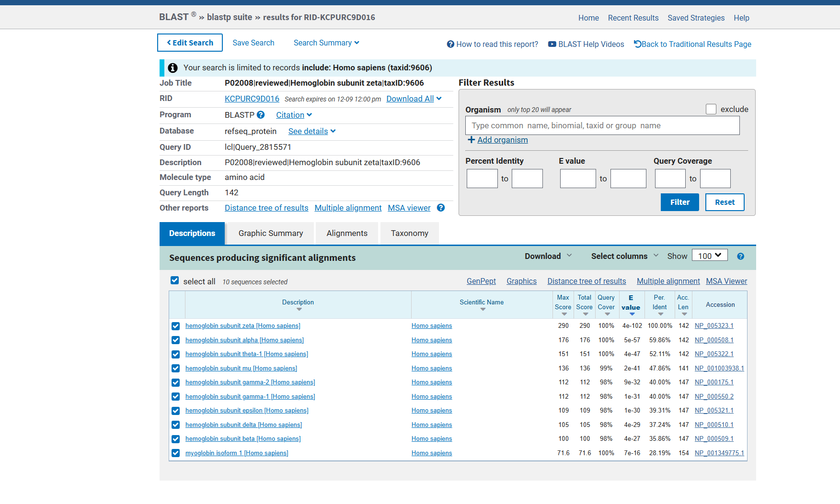
Figure 2: BLASTp results for Hemoglobin Subunit Zeta. Note the inclusion of Myoglobin (isoform 1) at the bottom of the list, which was absent in the top hits of the Alpha search.

Experiment C: Query using Hemoglobin Subunit Delta (HBD)
Querying with Hemoglobin Delta resulted in very strong matches for the Beta-globin cluster (Beta, Epsilon, Gamma), with E-values nearing 1e-100. It also successfully cross-identified the Alpha-globin cluster. However, as shown in Figure 3, the list cuts off after Hemoglobin Mu (6e-23), failing to retrieve Myoglobin or Neuroglobin.

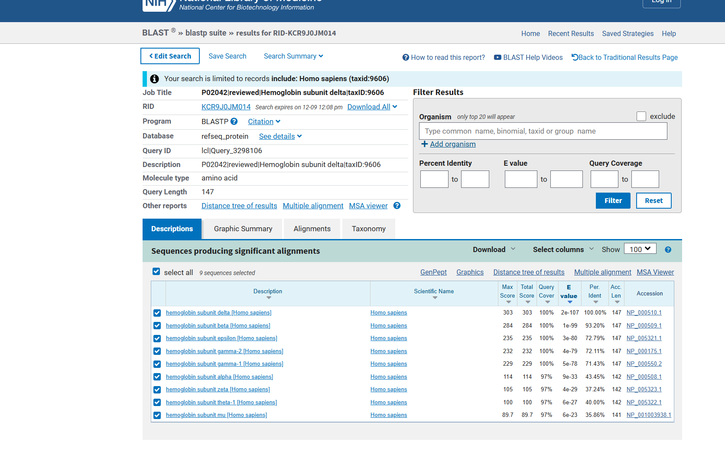
Figure 3: BLASTp results for Hemoglobin Subunit Delta. The search detects the major hemoglobin clusters but is less sensitive than the Zeta query, failing to retrieve Myoglobin in the top hits.
4. Discussion
4.1 Comparative Completeness
The results demonstrate that the PFam HMM list is superior in completeness. The HMM utilizes a probabilistic model of the entire protein family, allowing it to capture conserved structural residues even in the absence of high sequence identity. Consequently, PFam retrieved all 12 human globins simultaneously.
In contrast, BLAST results were highly query-dependent. When starting with different family members (Alpha vs. Zeta vs. Delta), the list of retrieved homologs changed. For example, Myoglobin was found when using Zeta (Figure 2) but missed when using Alpha (Figure 1) or Delta (Figure 3) under the same default display settings. None of the standard BLAST searches successfully identified Neuroglobin or Cytoglobin in the top hits, as these share less than 25% sequence identity with the queries.

4.2 E-value Threshold Analysis
The analysis reveals that no single strict E-value threshold allows BLAST to replicate the PFam list.
- The "Core" Hemoglobins are reliably detected with thresholds of 1e-20 or lower.
- To detect Myoglobin using HBZ, a threshold of 1e-15 is sufficient.
- However, to detect the missing Neuroglobin or Cytoglobin, the E-value threshold must be raised to approximately 0.05. Raising the threshold to this level increases the false discovery rate, as unrelated proteins begin to appear in the results.

5. Conclusion
This study confirms that while BLAST is a powerful tool for identifying close orthologs, it is insufficient for characterizing diverse protein families. The HMM approach (PFam) is the necessary tool for comprehensive proteome annotation, as it bridges the gap between distant evolutionary relatives that have retained structural homology despite significant sequence divergence.
All the files upload on the githubs.

